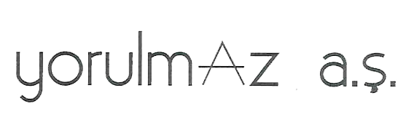

....................... EMBASSY ANKARA
10/02/2024

MY SON, ÖZGÜR ALİ YORULMAZ, WILL VISIT YOUR COUNTRY BETWEEN 12/02/2024 - 15/02/2024 DATES AS A TOURIST. I KINDLY ASK YOU TO ISSUE THE NECESSARY VISA.
ALL KINDS OF EXPENSES HE WILL MAKE DURING HIS STAY IN YOUR COUNTRY ARE UNDER GUARANTEE AND WILL BE COVERED BY ME.

WITH BEST REGARDS;

Ozan Aykut YORULMAZ

